**Retail Management System**

**A Project Report**

***Submitted by***

**Name of Student -Arjun Doshi**

**Name of Student -Aryan Shah**

**Name of Student -Ananya Giliyal**

**Name of Student - Aashna Shah**

***Under the Guidance of***

## Prof. KRISHNA SAMDANI

## B. TECH

## COMPUTER ENGINEERING

## At



**MUKESH PATEL SCHOOL OF TECHNOLOGY, MANAGEMENT AND ENGINEERING**

**DECLARATION**

I, **Arjun Doshi**, Roll No. **J053** B.Tech Data Science (2024), understand that plagiarism is defined as anyone or combination of the following:

1. Un-credited verbatim copying of individual sentences, paragraphs or illustration (such as graph diagrams, etc.) from any source, published or unpublished, including the internet.
2. Un-credited improper paraphrasing of pages paragraphs (changing a few words phrases, or rearranging the original sentence order)
3. Credited verbatim copying of a major portion of a paper (or thesis chapter) without clear delineation of who did wrote what. (Source: IEEE, The institute, Dec. 2004)
4. I have made sure that all the ideas, expressions, graphs, diagrams, etc., that are not a result of my work, are properly credited. Long phrases or sentences that had to be used verbatim from published literature have been clearly identified using quotation marks.
5. I affirm that no portion of my work can be considered plagiarism and I take full responsibility if such a complaint occurs. I understand fully well that the guide of the seminar/ project report may not be in a position to check for the possibility of such incidences of plagiarism in this body of work.

|  |  |  |
| --- | --- | --- |
| Signature of the Student: | Signature of the Student: | Signature of the Student: |
|  |  |  |
| Name: Aryan Shah | Name: Ananya Giliyal | Name: Aashna Shah |
|  |  |  |
| Roll No: J047 | Roll No: J003 | Roll No: J042 |
|  |  |  |
| Place: Mumbai | Place: Mumbai | Place: Mumbai |
|  |  |  |
| Date: 2.5.21 | Date: 2.5.21 | Date: 2.5.21 |
|  |  |  |

# Table of Contents

|  |  |  |
| --- | --- | --- |
| **CHAPTER NO.** | **TITLE** | **PAGE NO.** |
|  | List of Figures | I |
|  | Abstract | II |
| 1. | INTRODUCTION | 1 |
| 2. | TOOLS & TECHNIQUES | 1 |
| 3. | SIMULATIONS & RESULTS | 2 |
| 4. | CONCLUSION | 15 |
| 5. | FUTURE WORK | 15 |
| 6. | REFERENCES | 15 |
|  | Appendix A | 16 |
|  |  |  |

**Table of Figure**s

|  |  |  |  |
| --- | --- | --- | --- |
| CHAPTER  NO. | FIGURE  NO. | FIGURE NAME | PAGE  NO. |
| 3. | 1. | Global Editable Database of Products | 2 |
| 3. | 2. | User Friendly Billing System | 3 |
| 3. | 3. | Bill Shown to the User | 3 |
| 3. | 4. | Transaction Copied on CSV File | 4 |
| 3. | 5. | Code to Encrypt the Customer Password | 5 |
| 3. | 6. | Encryption of Password in CSV | 6 |
| 3. | 7. | Login Screen | 6 |
| 3. | 8. | Admin Screen | 6 |
| 3. | 9. | Customer Screen | 7 |
| 3. | 10. | Customer Section | 7 |
| 3. | 11. | Inventory Screen | 8 |
| 3. | 12. | Inserting New Products | 8 |
| 3. | 13. | Display of Entire Inventory | 9 |
| 3. | 14. | Search Command | 10 |
| 3. | 15. | Customer Login | 11 |
| 3. | 16. | Customer Sign Up | 12 |
| 3. | 17. | Users CSV File | 12 |
| 3. | 18. | Customer Option | 12 |
| 3. | 19. | Purchase Screen | 13 |
| 3. | 20. | Bill | 13 |
| 3. | 21. | Billing CSV | 14 |

**Abstract**

Shops fall short of their purpose without a proper and effective billing system for their daily sales. Billing systems are ways of management and monitoring all of the sales. As a business grows with its increasing number of locations, departments, items, and transactions, making invoices and managing orders by manual means are almost unworkable. The billing software is vital to complete this task.

One often faces issues in the billing process and is not satisfied with the efficiency of the billing system. There are delays in searching for products and prices.

Our project is a simple console application designed to demonstrate the practical use of the C programming language and its features. We decided to build an integrated system where billing is efficient in searching for store products, viewing stock levels, and printing receipts. We tried to generate an application accessible to the employees and customers.

Our software is easily accessible and can be used by small businesses too. By empowering these small businesses that stimulate economic growth, we could contribute to the welfare of humanity. Hence, our tool could help people globally to manage their sales, inventories, employees, and customers. Our program is very convenient and uses an authentic billing system

# Introduction

Our project is an easy-to-learn and hassle-free software interface. It includes the following features: Admin and Customer Login, Customer purchase history, Importing items, Tracking Inventory, Inventory counts, Print receipts, Tax invoice, Inventory history, Discount Reward, Customer base.

The program has integrated the admin back-office and customer login with passwords for security purposes. The back office can add items, identify customers with their accounts and also track total purchase history.

You can print receipts with applied discounts and tax amounts on the total bill.

Track the stock of products and gain insights into the inventory flow. Receive information about low stock to make the necessary item orders in time. The Discount Reward program motivates customers to make recurring purchases by awarding them discounts on their billing total if they win the game.

# Tools and Techniques

We have used Visual Studio Code (VSC) as our primary integrated development environment. Visual studio is a faster and lighter software as compared to the other IDE’s. VSC is a user-friendly and cross-platform which includes various extensions and works on multiple platforms.

Multiple projects containing files and folders can be opened simultaneously. These projects/folders might or might not be related to each other. VSC has a feature called Intelli-Sense which can detect if any snippet of code is left incomplete. Common variable syntaxes and variable declarations are made automatically on VSC.

The devices used for writing and executing this code are HP spectre X360 (RAM 16GB) and MacBook Air 2020 (RAM 8 GB).

# Simulation and Results

## 3.1: Problem Set

The lack of a singular local system for small retailers was a problem we chose to confront. Having a user and admin - based system would allow ease of operations. We decided to create a simple but effective program to tackle this issue.

## 3.2: Solution Design

Solution design talks about how we implemented each problem and crafted a solution.

1. Global editable database of products

A predefined global array list allows the program to access all the products effectively in a simple way. It is edited as per customers' requirements beforehand. Having a globally defined dataset like this is convenient because it allows each function to access the products.

Figure 1: Global editable database of products

Each of these arrays represent a category of items with their unique code, price and stock, all of which are editable by the user which will be explained in navigation.

1. User friendly billing system:

A billing system that allows you to be the administrator and keep a track of daily billing transactions made is essential. The owner can have sole rights to the daily billing .csv file making it extremely secure.

Figure 2: User Friendly Billing System

This is a snippet of the code that actually transfers the billing data into the .csv file. The variable bill number represents the transactions on one particular working day. We have assumed that the admin opens the program once a day and closes it at the end of the day.

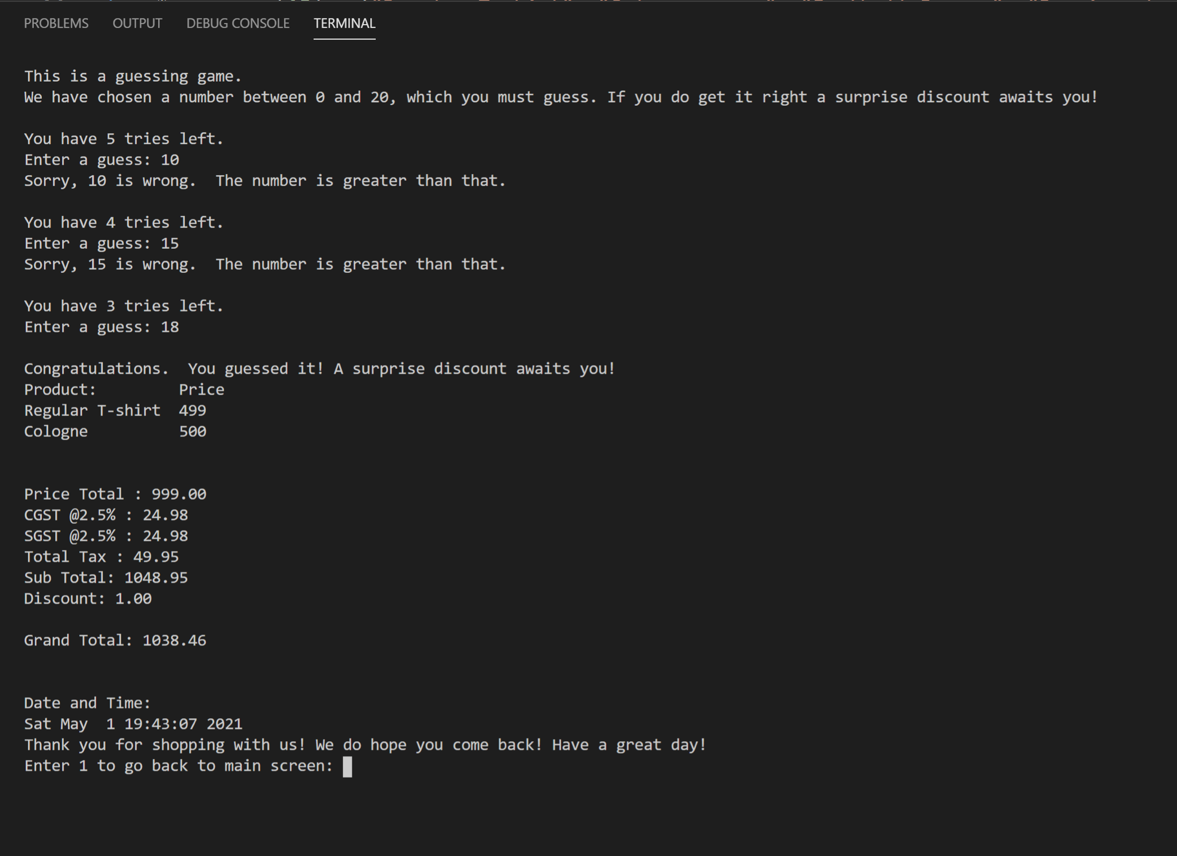

Figure 3: Bill shown to the user

This shows the user end bill.

In real time, this bill is transferred to the admin daily bill in .csv file. This is the first transaction of the day.

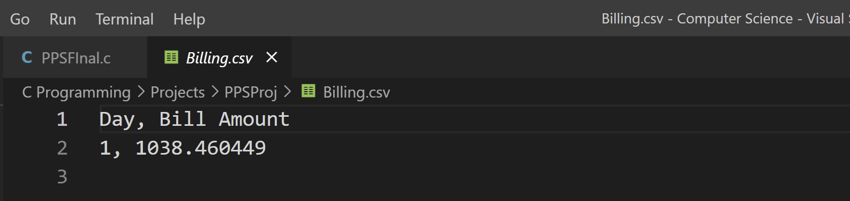

Figure 4: Transaction copied on csv file

1. Encrypted Customer Database

In today’s digital age, having data from your customers without infringing on privacy is extremely important. We allow the admin to access users info only if required for business reasons.

Figure 5:Code to encrypt customer password

This is a snippet of the code that allows the username and encrypted password to be stored safely in an encrypted .csv file.

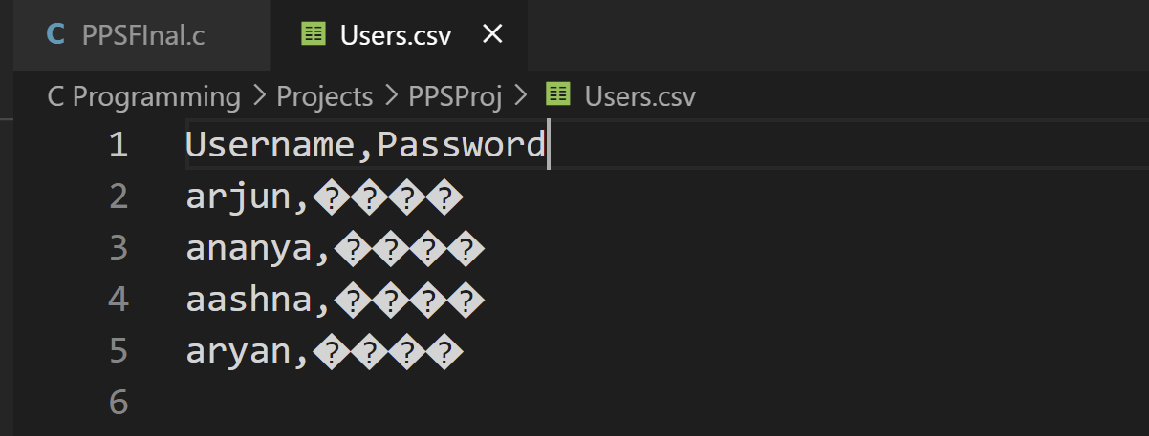

Figure 6: Encryption of password in csv

1. Providing Menu based interface for easy access

This was achieved using the Switch Case functions.

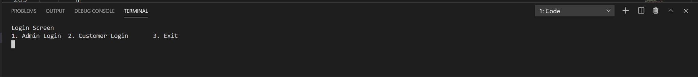

Figure 7:Login Screen

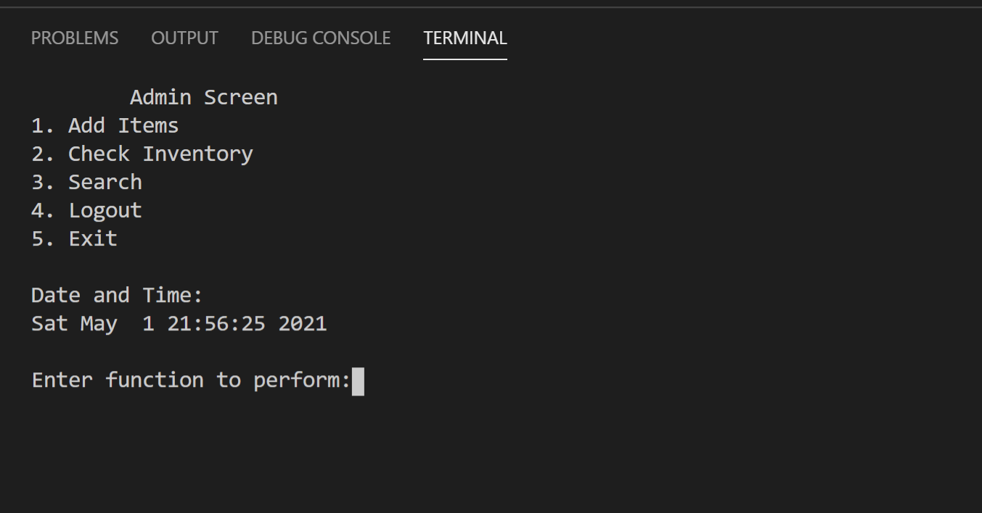

Figure 8: Admin Screen

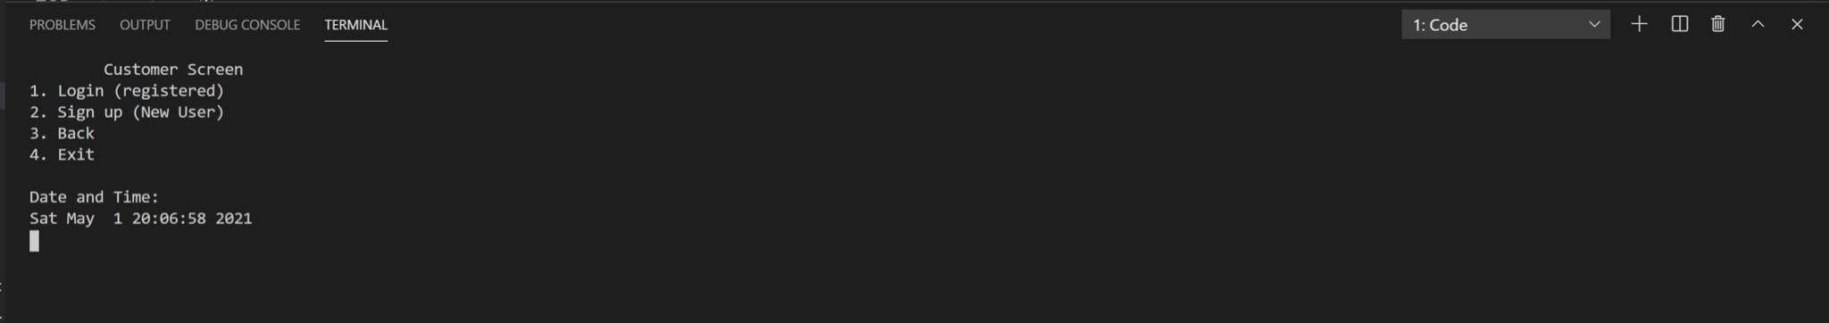

Figure 9:Customer Screen

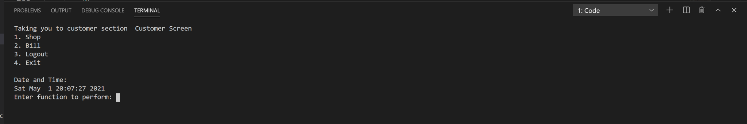

Figure 10: Customer Section

## 3.3: Simulation (Navigation)

This program executes all its functions based on the user's choices. A great deal of time went into learning what the user might input. If an incorrect input is given, how to make it user friendly and allow smooth flow of the program.

Troubleshooting issues and creating small tests for each function in separate files has been an important part of the learning process as well as writing clean code.

**On running the code:**

The user is either an admin or customer and will choose accordingly:

int main()

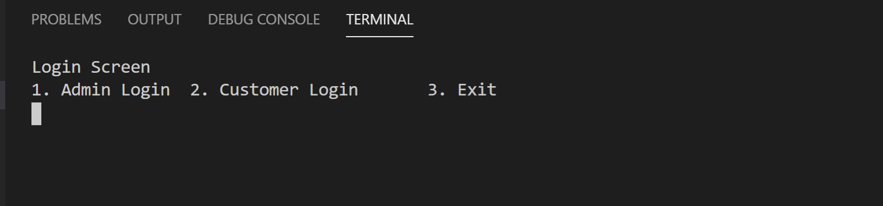

1. **Admin:**

void admin();



A prompt for password comes through for security purpose. Once putting the correct password:

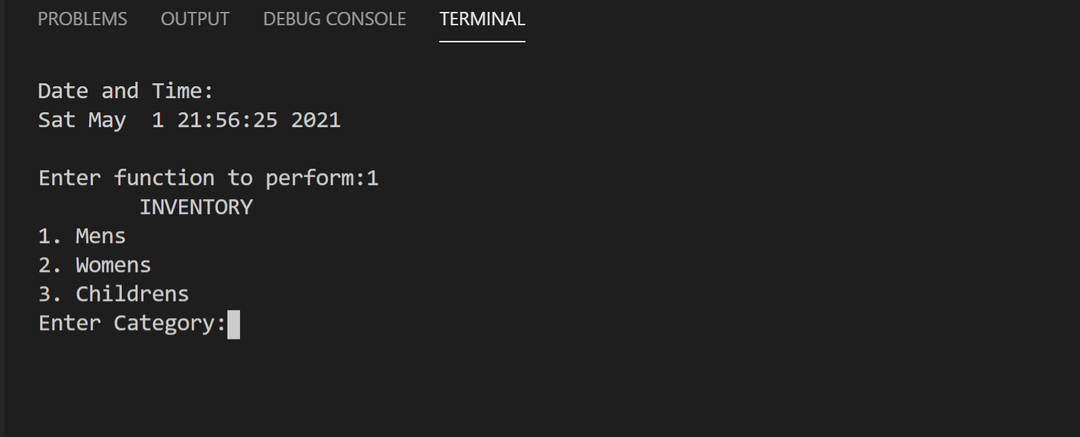

Figure 11: Inventory Screen

Admin can choose which category and function takes that as input

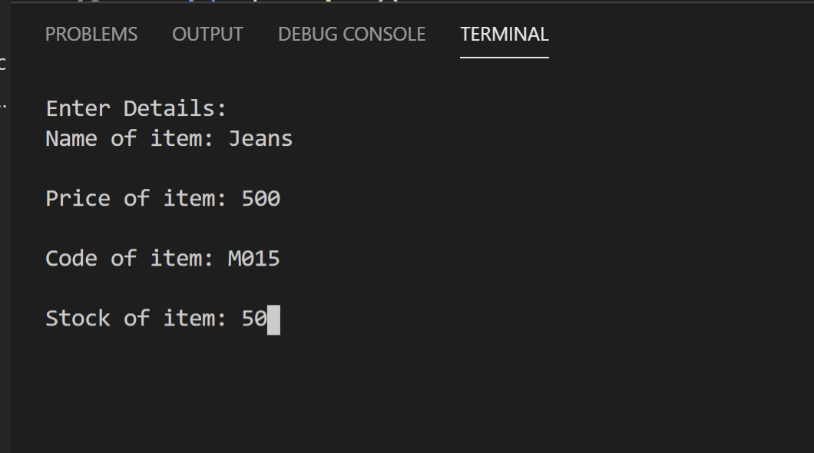

Figure 12: Inserting New Products

The newly added product with its details are visible on the inventory section. The items out of stock such as C01 are also mentioned below for the admin to view.

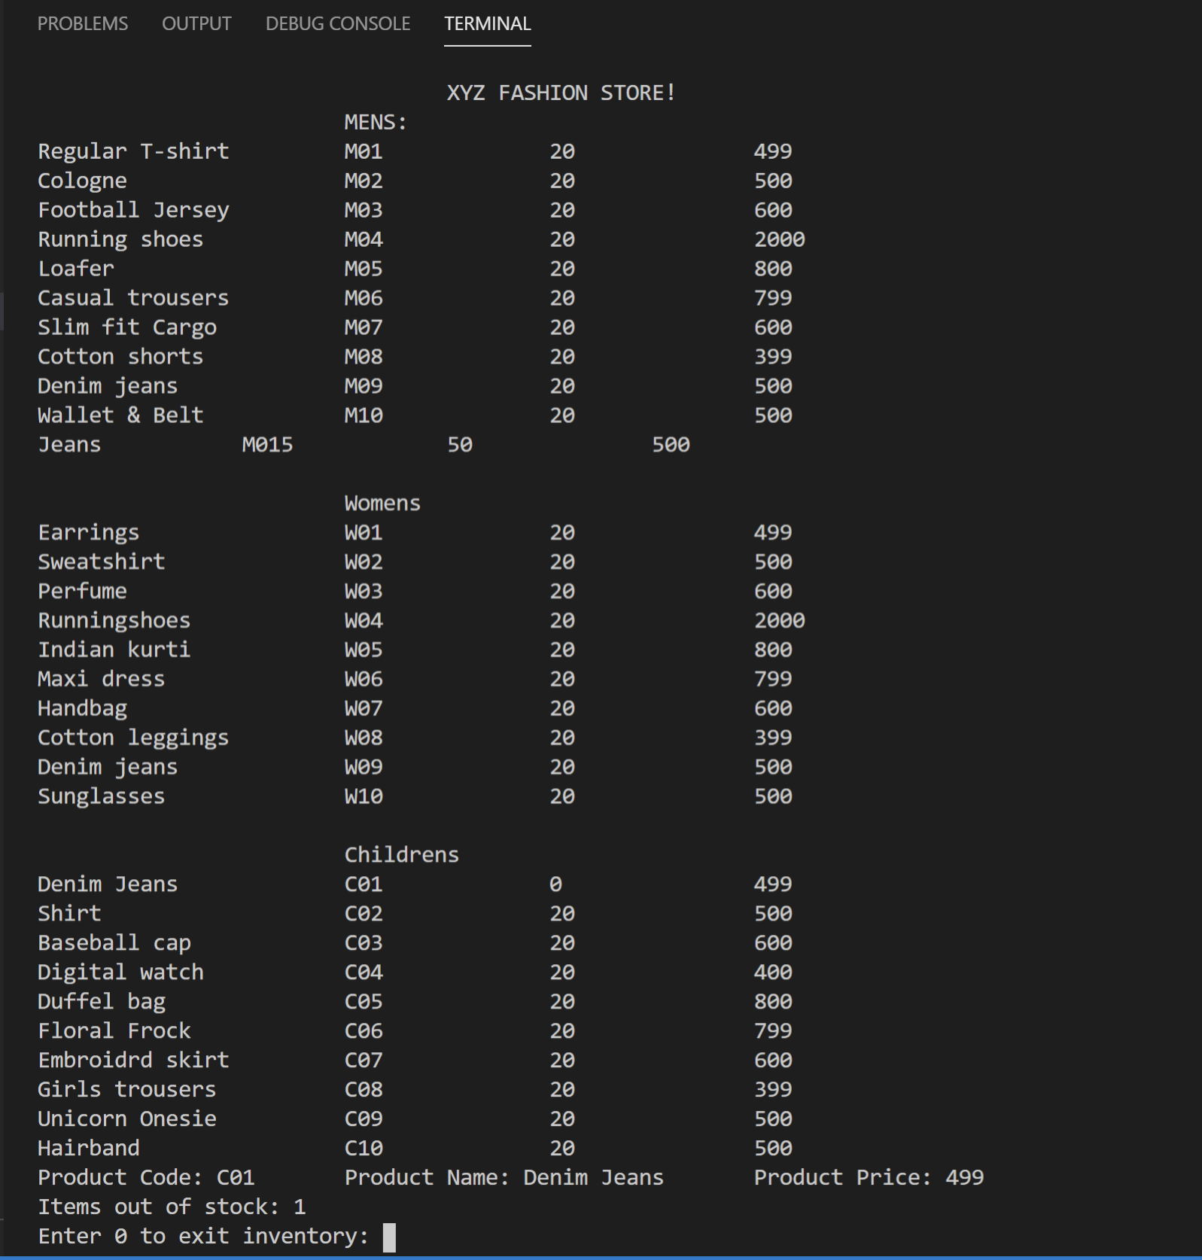

Figure 13:Display of Entire Inventory

void search();

The newly added item can be searched using its own unique code. This also allows searching of all products in the inventory multiple times using the same function as required.

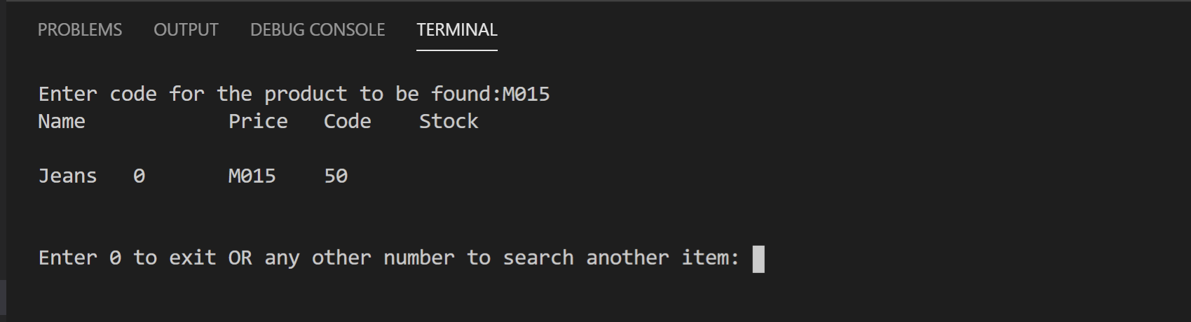

Figure 14: Search Command

1. **Customer:**

int customerLogin();

The customer is either a new user or an old member. They can choose accordingly.

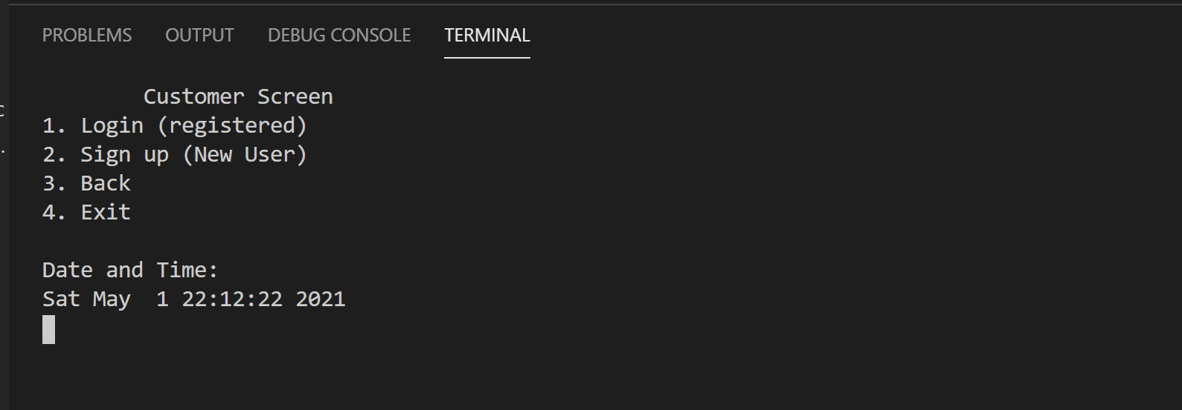

int accountChecker();

const char *getfield(char *line, int num);

* Customer Login:

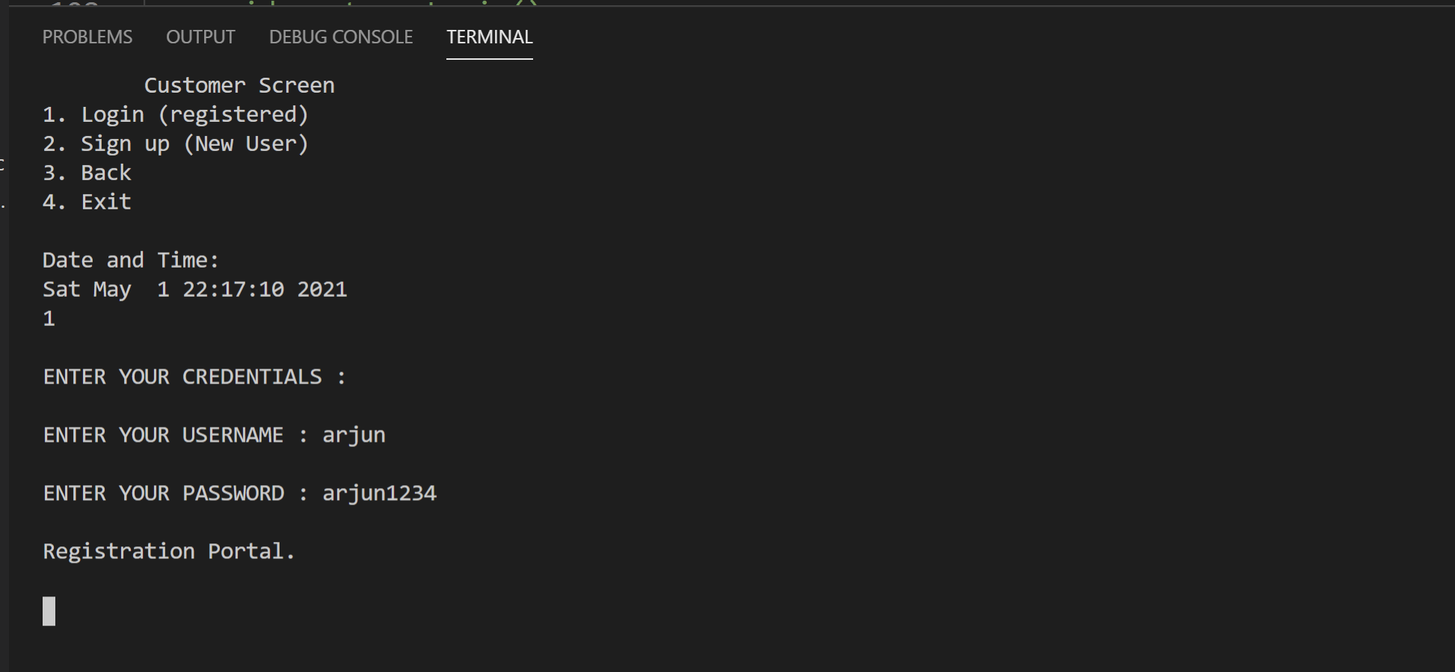

Figure 15: Customer Login

In case user inputs wrong values of username and password it redirects them to the Customer Login screen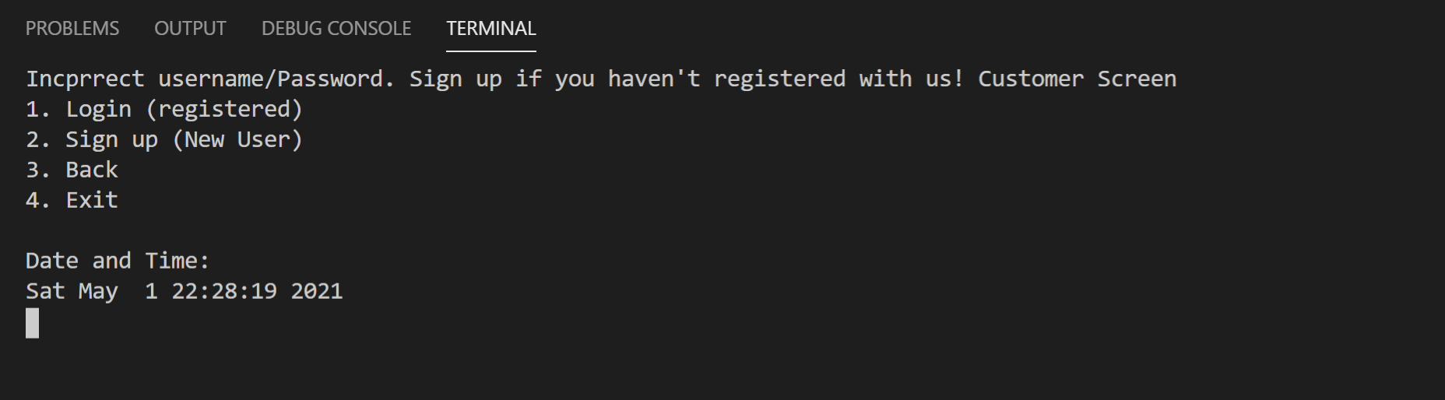

* Customer Sign up:

void newUser();

This function successfully adds a new user to the Users.csv file with the necessary details.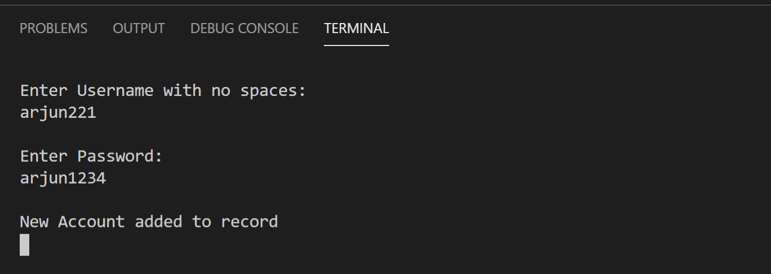

Figure 16: Customer Sign Up

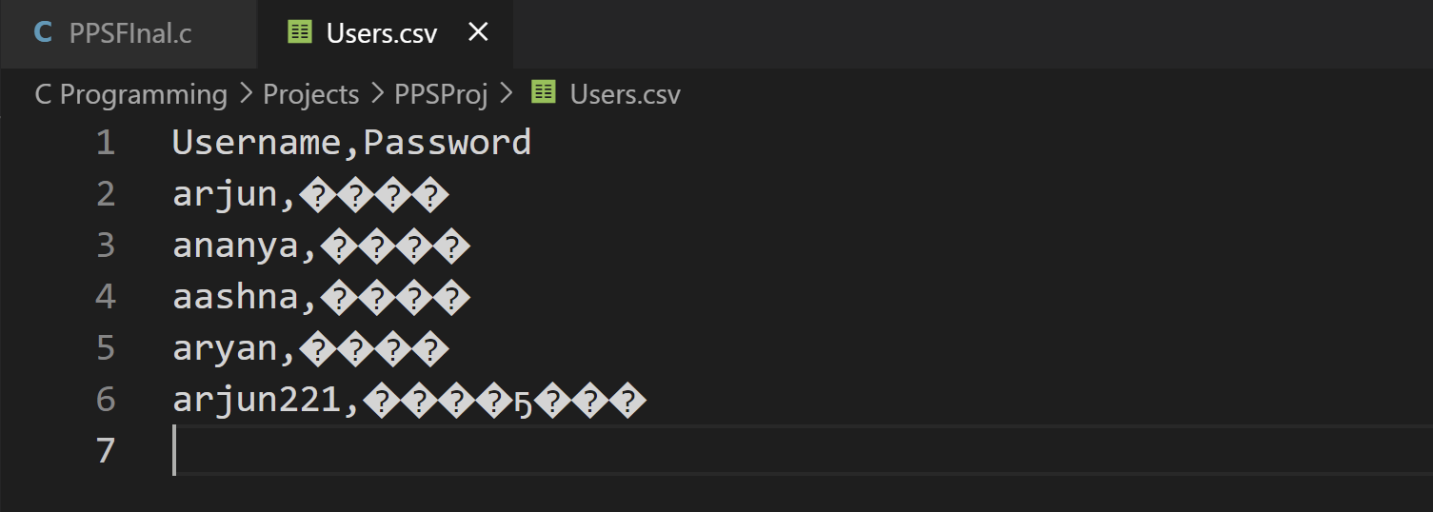

Figure 17: Users CSV

void customer()

Once either signed up or logged in the customer options open up. 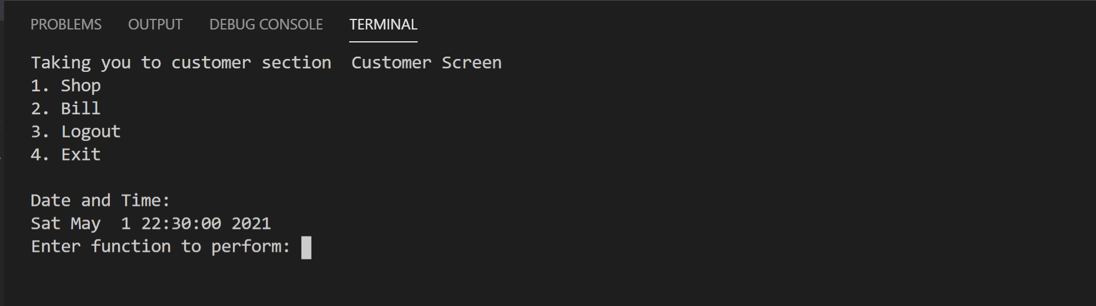

Figure 18: Customer Options

void shopping();

This function allows customer to buy products 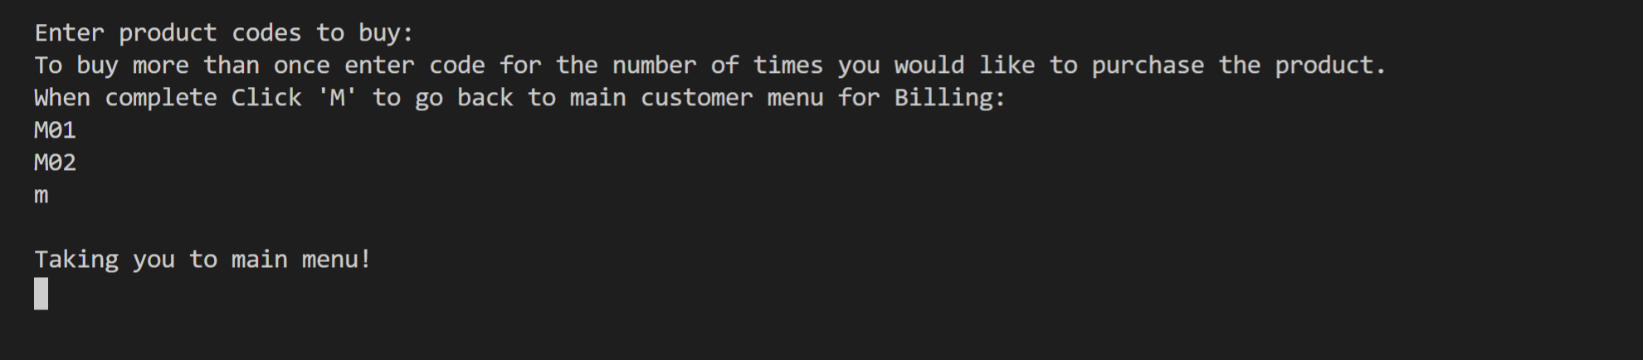

Figure 19:Purchase Screen

These functions perform the billing whilst giving the user an opportunity to play our signature Discount Reward game.

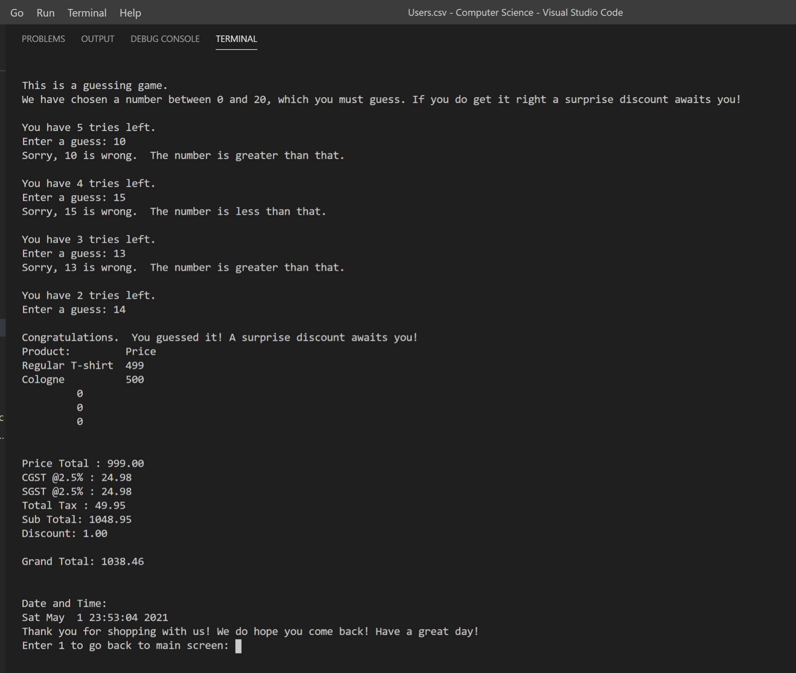

Figure 20: Bill

This gets successfully added into daily bill records.

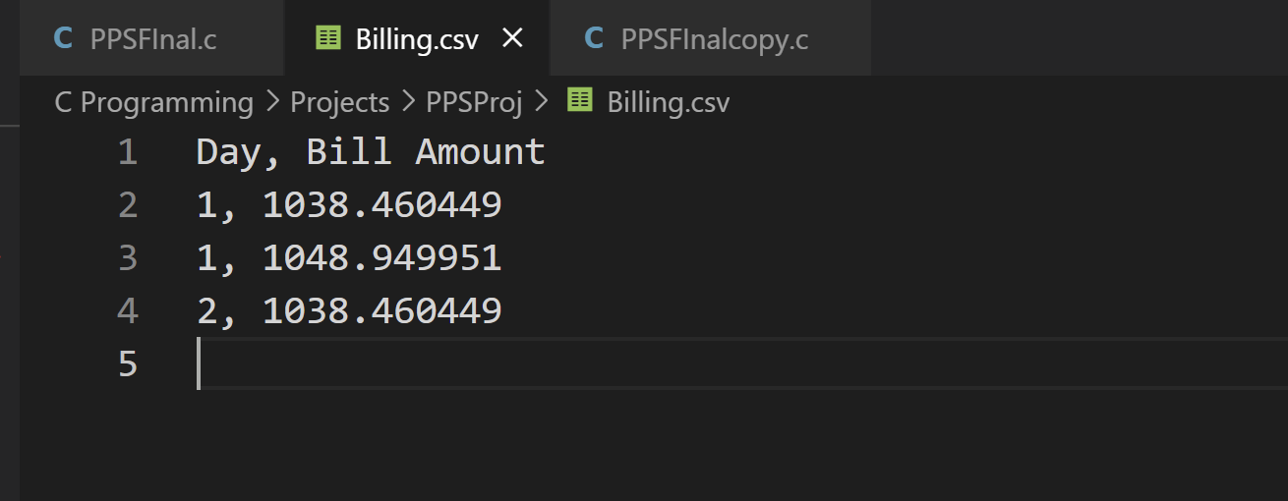

Figure 21: Billing CSV

1. **Complimentary functions:**

void d_time();

This function displays time at all the places seen above.

void display();

This function displays the entire menu at a particular when invoked.

int passwordCheckAdmin();

This function checks for the admin password which is predefined.

## 3.4 Result:

The end result of this program is a fully functional retail database system which works flawlessly with utmost privacy as well as in an extremely user friendly way.

# Conclusion

With our program, you can manage inventory, sales, and employees with ease. Engage customers and increase your revenue with our customer database. The integration of customer service and the admin back office is an essential feature of our program. Irrespective of whether you have a single store or multiple ones, you can use our tool to run your business. If this code is enhanced, it could be an alternate format for the modern-day billing and online retail system.

# Future Work

According to us, the future applications of this project are vital in its productivity. The system is local and offline but, it could be an online application.

The admin system is on the same software as the customer profile. As of now, we have listed products that would be relevant to a fashion outlet. If the admin changes the product type and quantity, it could expand the inventory. In the future, this would cover a variety of products. Thus, multiple outlets could access it.

The system informs the admin user of low stock levels. Upgradation of the software could find the most profitable company to buy the stock when the stock levels are low. This upgrade would positively affect the sales, ensuring that the system would not be out of stock. We have introduced a game called the Discount Reward to increase the involvement of the customers. In the future, we could take constructive feedback from our loyal customers into consideration and further develop the project.

# References

* Java point : https://www.javatpoint.com/file-handling-in-c
* GeeksforGeeks :<https://www.geeksforgeeks.org/relational-database-from-csv-files-in-c/>
* Stack overflow :<https://stackoverflow.com/questions/5141960/get-the-current-time-in-c>

**Appendix A**

#include <stdio.h>

#include <stdlib.h>

#include <time.h>

#include <string.h>

#include <windows.h>

int m = 10, w = 10, chi = 10;

int cipherKey = 100;

/*

Maximum 15 items per category

*/

/*----------------------------- Mens --------------------------------*/

char *mens_name[15] = {"Regular T-shirt", "Cologne      ", "Football Jersey", "Running shoes", "Loafer    ", "Casual trousers", "Slim fit Cargo", "Cotton shorts", "Denim jeans", "Wallet & Belt"};

int mens_price[15] = {499, 500, 600, 2000, 800, 799, 600, 399, 500, 500};

char *mens_code[15] = {"M01", "M02", "M03", "M04", "M05", "M06", "M07", "M08", "M09", "M10"};

int mens_stock[15] = {20, 20, 20, 20, 20, 20, 20, 20, 20, 20};

/*---------------------------- Womens --------------------------------*/

char *womens_name[15] = {"Earrings", "Sweatshirt", "Perfume     ", "Runningshoes", "Indian kurti", "Maxi dress", "Handbag   ", "Cotton leggings", "Denim jeans", "Sunglasses"};

int womens_price[15] = {499, 500, 600, 2000, 800, 799, 600, 399, 500, 500};

char *womens_code[15] = {"W01", "W02", "W03", "W04", "W05", "W06", "W07", "W08", "W09", "W10"};

int womens_stock[15] = {20, 20, 20, 20, 20, 20, 20, 20, 20, 20};

/*--------------------------- Children -------------------------------*/

char *child_name[15] = {"Denim Jeans", "Shirt   ", "Baseball cap", "Digital watch", "Duffel bag", "Floral Frock", "Embroidrd skirt", "Girls trousers", "Unicorn Onesie", "Hairband"};

int child_price[15] = {499, 500, 600, 400, 800, 799, 600, 399, 500, 500};

char *child_code[15] = {"C01", "C02", "C03", "C04", "C05", "C06", "C07", "C08", "C09", "C10"};

int child_stock[15] = {0, 20, 20, 20, 20, 20, 20, 20, 20, 20};

//Main Functions

void admin();

int passwordCheckAdmin();

int customerLogin();

//Admin Functions Declaration

void add(int cat);

void inventory();

void search();

void display();

//CustomerLogin Functions Declaration

void customer();

int accountChecker();

const char *getfield(char *line, int num);

void newUser();

//Customer Functions Declaration

void shopping();

void billing();

int game();

void d_time();

char prodCodes[45][100]; //Final Bill Codes

char products[45][100];  //Final Bill Product Names

int prodPrice[45];       //FInal Product Prices

int no = 1, customerCall = 0;

int checkerForShopping = 0;

int billNumber = 1;

struct bill

{

    float price;

    float tax;

    float discount;

    float sub_total;

    float grand_total;

};

int main()

{

    system("clear");

    int login;

    printf("Login Screen\n1. Admin Login\t2. Customer Login\t3. Exit\n");

    scanf("%d", &login);

    do

    {

        switch (login)

        {

        case 1:;

            if (passwordCheckAdmin() == 0)

                admin(); //Admin Function call

            break;

        case 2:

            customerLogin(); //Customer Login Database

            break;

        case 3:

            exit(0);

            break;

        default:

            printf("Enter correct input:\n 1. Admin Login\t2. Customer Login\t3. Exit\n");

            scanf("%d", &login);

        }

    } while (login != 1 || login != 2 || login != 3);

    return 0;

}

/**

    Main Functions

    void admin();

    int passwordCheck();

    void customerLogin();

*/

void admin()

{

    /**

        Admin Functions:

        void add(int cat);

        void inventory(int op);

        void search(int op);

        void display();

     */

    system("clear");

    int option;

    printf("\tAdmin Screen\n1. Add Items\n2. Check Inventory \n3. Search \n4. Logout\n5. Exit\n");

    d_time();

    printf("\nEnter function to perform:");

    scanf("%d", &option);

    int cat;

    do

    {

        switch (option)

        {

        case 1:

            printf("\tINVENTORY\n1. Mens\n2. Womens\n3. Childrens\nEnter Category:");

            scanf("%d", &cat);

            add(cat);

            break;

        case 2:

            system("clear");

            inventory();

            break;

        case 3:

            system("clear");

            search();

            break;

        case 4:

            system("clear");

            main();

            break;

        case 5:

            exit(0);

            break;

        default:

            printf("Enter correct input\n");

            scanf("%d", &option);

        }

    } while (option != 1 || option != 2 || option != 3 || option != 4 || option != 5);

}

int passwordCheckAdmin()

{

    int cp = 124;

    int ep;

    printf("Enter password\n");

    scanf("%d", &ep);

    if (ep == cp)

    {

        return 0;

    }

    else

    {

        return 1;

        while (ep != cp)

        {

            printf("Incorrect password\n");

            printf("Enter password\n");

            scanf("%d", &ep);

        }

    }

}

/*

    CustomerLogin Functions Declaration

    void customer();

    int accountChecker();

    const char *getfield(char *line, int num);

    void newUser();

*/

int customerLogin()

{

    system("clear");

    int option;

    printf("\tCustomer Screen\n1. Login (registered) \n2. Sign up (New User)\n3. Back \n4. Exit\n");

    d_time();

    scanf("%d", &option);

    do

    {

        switch (option)

        {

        case 1:

            accountChecker();

            break;

        case 2:

            newUser();

            break;

        case 3:

            system("clear");

            main();

            break;

        case 4:

            exit(0);

            break;

        default:

            printf("Enter correct input\n");

            scanf("%d", &option);

        }

    } while (option != 1 || option != 2 || option != 3 || option != 4 || option != 5);

}

int accountChecker()

{

    int c = 0;

    char *name[100];

    char password[50];

    printf("\nENTER YOUR CREDENTIALS : \n");

    printf("\nENTER YOUR USERNAME : ");

    scanf("%s", name);

    printf("\nENTER YOUR PASSWORD : ");

    scanf("%s", password);

    char comma[50] = ",";

    const char *tp1[100];

    const char *tp2[100];

    char encrypted[50];

    int i;

    int a;

    for (i = 0; (i < 50 && password[i] != '\0'); i++)

    {

        encrypted[i] = password[i] + cipherKey;

        a = i;

    }

    encrypted[a] = password[a] + cipherKey;

    encrypted[a + 1] = '\0';

    strcpy(tp1, strcat(name, comma));

    strcpy(tp2, strcat(tp1, encrypted));

    tp2[strlen(tp2)] = '\n';

    FILE *filePointer = fopen("Users.csv", "r");

    if (filePointer == NULL)

    {

        printf(" file failed to open.\n");

    }

    else

    {

        printf(" \nRegistration Portal.\n");

        int eof = 0;

        int count = 0;

        char buffer[1024];

        while (fgets(buffer, 1024, filePointer))

        {

            char *tmp = strdup(buffer);

            const char *usernamePassword[100];

            char *cpy;

            int n, i;

            strcpy(usernamePassword, getfield(tmp, 1));

            i = strlen(usernamePassword);

            cpy = (char *)malloc(i);

            strncpy(cpy, usernamePassword, i - 1);

            cpy[i - 1] = '\0';

            eof = eof + EOF;

            if ((n = strcmp(tp2, cpy)) == 0)

            {

                printf("\nTaking you to customer section");

                Sleep(3000);

                customer();

            }

            else

            {

                count--;

            }

            free(cpy);

            free(tmp);

        }

        if (count == eof)

        {

            printf("\nIncprrect username/Password. Sign up if you haven't registered with us!");

            Sleep(3000);

            customerLogin();

        }

    }

}

const char *getfield(char *line, int num)

{

    const char *tok;

    for (tok = strtok(line, ";");

         tok && *tok;

         tok = strtok(NULL, ";\n"))

    {

        if (!--num)

            return tok;

    }

    return NULL;

}

void newUser()

{

    system("clear");

    FILE *fp = fopen("Users.csv", "a+");

    char name[50], password[50];

    if (!fp)

    {

        // Error in file opening

        printf("Can't open file\n");

        Sleep(3000);

        main();

    }

    // Asking user input for the

    // new record to be added

    printf("\nEnter Username with no spaces:\n");

    scanf("%s", &name);

    printf("\nEnter Password: \n");

    scanf("%s", &password);

    char encrypted[50];

    int i;

    int a;

    for (i = 0; (i < 50 && password[i] != '\0'); i++)

    {

        encrypted[i] = password[i] + cipherKey;

        a = i;

    }

    encrypted[a] = password[a] + cipherKey;

    encrypted[a + 1] = '\0';

    // Saving data in file

    fprintf(fp, "%s,%s\n", name, encrypted);

    printf("\nNew Account added to record");

    fclose(fp);

    printf("\nTaking you to customer section");

    Sleep(3000);

    customer();

}

void customer()

{

    /**

        Customer Functions:

        void shopping(int op);

        void billing();

        int game();

        void d_time();

        void cart();

     */

    system("clear");

    int option;

    printf("\tCustomer Screen\n1. Shop\n2. Bill\n3. Logout \n4. Exit\n");

    d_time();

    printf("Enter function to perform: ");

    scanf("%d", &option);

    do

    {

        switch (option)

        {

        case 1:

            system("clear");

            shopping();

            break;

        case 2:

            system("clear");

            billing();

            break;

        case 3:

            system("clear");

            main();

            break;

        case 4:

            exit(0);

            break;

        default:

            printf("Enter correct input\n");

            scanf("%d", &option);

        }

    } while (option != 1 || option != 2 || option != 3 || option != 4);

}

/*------------------------------------------------ Functions -------------------------------------------------------*/

/*Customer Functions*/

void shopping()

{

    system("clear");

    display();

    checkerForShopping++;

    printf("\nEnter product codes to buy:\nTo buy more than once enter code for the number of times you would like to purchase the product.\nWhen complete Click 'M' to go back to main customer menu for Billing:\n");

    for (int i = 0; i < no; i++)

    {

        scanf("%s", prodCodes[i]);

        no++;

        if (strcmp(prodCodes[i], "m") == 0 || strcmp(prodCodes[i], "M") == 0)

        {

            printf("\nTaking you to main menu!\n");

            Sleep(3000);

            customerCall++;

            break;

        }

    }

    if (customerCall != 0)

    {

        customer();

    }

}

void billing()

{

    struct bill bill;

    system("clear");

    if (checkerForShopping == 0)

    {

        system("clear");

        printf("Oh no you haven't purchased anything! Find exciting new fashion at out shopping section!\nPress 1 to go back to main menu: ");

        int n;

        scanf("%d", &n);

        if (n == 1)

            customer();

    }

    else if (prodCodes[1] == 0)

    {

        system("clear");

        printf("Oh no you haven't purchased anything! Find exciting new fashion at out shopping section!\nPress 1 to go back to main menu: ");

        int n;

        scanf("%d", &n);

        if (n == 1)

            customer();

    }

    else

    {

        float b_mens = 0.0, b_womens = 0.0, b_child = 0.0;

        int c1 = 0, c2 = 0;

        for (int i = 0; i < no - 2; i++)

        {

            //searchCounter(product);

            for (int j = 0; j < m; j++) //iterate over category

            {

                if (strcmp(prodCodes[i], mens_code[j]) == 0) //check product

                {

                    if (mens_stock[j] != 0) //check stock

                    {

                        mens_stock[j]--;

                        b_mens += mens_price[j];

                        strcpy(products[c1], mens_name[j]);

                        prodPrice[c1] = mens_price[j];

                        c1++;

                    }

                }

            }

            for (int j = 0; j < w; j++)

            {

                if (strcmp(prodCodes[i], womens_code[j]) == 0)

                {

                    if (womens_stock[j] != 0)

                    {

                        womens_stock[j]--;

                        b_womens += womens_price[j];

                        strcpy(products[c1], womens_name[j]);

                        prodPrice[c1] = womens_price[j];

                        c1++;

                    }

                }

            }

            for (int j = 0; j < chi; j++)

            {

                if (strcmp(prodCodes[i], child_code[j]) == 0)

                {

                    if (child_stock[j] != 0)

                    {

                        child_stock[j]--;

                        b_child += child_price[i];

                        strcpy(products[c1], child_name[j]);

                        prodPrice[c1] = child_price[j];

                        c1++;

                    }

                }

            }

        }

        bill.price = (b_mens + b_womens + b_child);

        int gameResult = game();

        if (gameResult == 1)

        {

            int randomNumber = 0;

            time_t t;

            // Initialization of random number generator

            srand((unsigned)time(&t));

            // get the random number

            randomNumber = rand() % 11;

            bill.discount = randomNumber;

        }

        else

        {

            bill.discount = 0;

        }

        float cgst, sgst;

        cgst = (0.025 * bill.price);

        sgst = (0.025 * bill.price);

        bill.tax = cgst + sgst;

        bill.sub_total = bill.price + bill.tax;

        if (bill.discount == 0)

        {

            bill.grand_total = bill.sub_total;

        }

        else

        {

            bill.grand_total = bill.sub_total - (bill.sub_total * (bill.discount / 100.0));

        }

        /*--------------------------------------------------------------------*/

        FILE *fp = fopen("Billing.csv", "a+");

        if (!fp)

        {

            // Error in file opening

            printf("Can't open file\n");

            Sleep(3000);

            customer();

        }

        // Saving data in file

        fprintf(fp, "%d, %f\n", billNumber, bill.grand_total);

        fclose(fp);

        billNumber++;

        /*-----------------------------------------------------------------------*/

        printf("Product:\t Price\n");

        for (int i = 0; i < no - 2; i++)

        {

            printf("%s\t %d\n", products[i], prodPrice[i]); //Final Bill Codes

        }

        printf("\n\nPrice Total : %0.2f\nCGST @2.5%% : %0.2f\nSGST @2.5%% : %0.2f\nTotal Tax : %0.2f\nSub Total: %0.2f\nDiscount: %0.2f\n\nGrand Total: %0.2f\n\n", bill.price, cgst, sgst, bill.tax, bill.sub_total, bill.discount, bill.grand_total);

        d_time();

        printf("** ** Thank you for shopping with us! We do hope you come back! Have a great day! ** **");

        int exit;

        printf("\nEnter any key to go back to main screen: ");

        scanf("%d", &exit);

        if (exit == 1)

        {

            customer();

        }

        else

        {

            customer();

        }

    }

}

int game()

{

    int randomNumber = 0;

    int guess = 0;

    int numberOfGuesses;

    time_t t;

    // Initialization of random number generator

    srand((unsigned)time(&t));

    // get the random number

    randomNumber = rand() % 21;

    printf("\nThis is a guessing game.");

    printf("\nWe have chosen a number between 0 and 20, which you must guess. If you do get it right a surprise discount awaits you! \n");

    int c = 0;

    for (numberOfGuesses = 5; numberOfGuesses > 0; --numberOfGuesses)

    {

        printf("\nYou have %d tr%s left.", numberOfGuesses, numberOfGuesses == 1 ? "y" : "ies");

        printf("\nEnter a guess: ");

        scanf("%d", &guess);

        if (guess == randomNumber)

        {

            printf("\nCongratulations.  You guessed it! A surprise discount awaits you!\n");

            c = 1;

            Sleep(3000);

            break;

        }

        else if (guess < 0 || guess > 20) // checking for an invalid guess

        {

            printf("The number is between 0 and 20.\n");

        }

        else if (randomNumber > guess)

        {

            printf("Sorry, %d is wrong.  The number is greater than that.\n", guess);

        }

        else if (randomNumber < guess)

        {

            printf("Sorry, %d is wrong.  The number is less than that.\n", guess);

        }

    }

    if (c == 0)

    {

        printf("\nYou have had five tries and failed. The number was %d. Sorry you do NOT get a discount :(\n", randomNumber);

        Sleep(3000);

    }

    else

        return c;

}

void d_time()

{

    char temp[100];

    time_t current_time = time(NULL);

    struct tm *tm = localtime(&current_time);

    strftime(temp, sizeof(temp), "%c", tm);

    printf("\nDate and Time:");

    printf("\n%s\n", temp);

}

/*Admin Functions*/

void add(int cat)

{

    if (cat == 1) //Mens

    {

        char name[25], code[10];

        int price, stock = 0;

        system("clear");

        printf("\nCode of item: ");

        scanf("%s", code);

        //codechecker

        for (int i = 0; i < m; i++)

        {

            if (strcmp(code, mens_code[i]) == 0)

            {

                printf("\nCode already exists. Enter a new code:\n ");

                Sleep(2000);

                add(1);

            }

        }

        mens_code[m] = code;

        // element to be inserted

        printf("\nEnter Details:");

        printf("\nName of item: ");

        scanf("%s", name);

        mens_name[m] = name;

        printf("\nPrice of item: ");

        scanf("%d", &price);

        mens_price[m] = price;

        printf("\nStock of item: ");

        scanf("%d", &stock);

        mens_stock[m] = stock;

        m++;

        system("clear");

        admin();

    }

    else if (cat == 2) //Womens

    {

        char name[25], code[10];

        int price, stock = 0;

        system("clear");

        printf("\nCode of item: ");

        scanf("%s", code);

        //codechecker

        for (int i = 0; i < w; i++)

        {

            if (strcmp(code, womens_code[i]) == 0)

            {

                printf("\nCode already exists. Enter a new code:\n ");

                Sleep(2000);

                add(2);

            }

        }

        womens_code[w] = code;

        // element to be inserted

        printf("\nEnter Details:");

        printf("\nName of item: ");

        scanf("%s", name);

        womens_name[w] = name;

        printf("\nPrice of item: ");

        scanf("%d", &price);

        womens_price[w] = price;

        printf("\nStock of item: ");

        scanf("%d", &stock);

        womens_stock[w] = stock;

        w++;

        system("clear");

        admin();

    }

    else if (cat == 3) //Childrens

    {

        char name[25], code[10];

        int price, stock = 0;

        system("clear");

        printf("\nCode of item: ");

        scanf("%s", code);

        //codechecker

        for (int i = 0; i < chi; i++)

        {

            if (strcmp(code, child_code[i]) == 0)

            {

                printf("\nCode already exists. Enter a new code:\n ");

                Sleep(2000);

                add(3);

            }

        }

        child_code[chi] = code;

        // element to be inserted

        printf("\nEnter Details:");

        printf("\nName of item: ");

        scanf("%s", name);

        child_name[chi] = name;

        printf("\nPrice of item: ");

        scanf("%d", &price);

        child_price[chi] = price;

        printf("\nStock of item: ");

        scanf("%d", &stock);

        child_stock[chi] = stock;

        chi++;

        system("clear");

        admin();

    }

    else

    {

        printf("\nWrong Input\n");

        Sleep(3000);

        admin();

    }

}

void inventory()

{

    display();

    int j = 0;

    for (int i = 0; i < m; i++)

    {

        if (mens_stock[i] == 0)

        {

            printf("\n\nProduct Code: %s\t", mens_code[i]);

            printf("Product Name: %s\t", mens_name[i]);

            printf("Product Price: %d\n", mens_price[i]);

            j++;

        }

    }

    for (int i = 0; i < w; i++)

    {

        if (womens_stock[i] == 0)

        {

            printf("\n\nProduct Code: %s\t", womens_code[i]);

            printf("Product Name: %s\t", womens_name[i]);

            printf("Product Price: %d\n", womens_price[i]);

            j++;

        }

    }

    for (int i = 0; i < chi; i++)

    {

        if (child_stock[i] == 0)

        {

            printf("\n\nProduct Code: %s\t", child_code[i]);

            printf("Product Name: %s\t", child_name[i]);

            printf("Product Price: %d\n", child_price[i]);

            j++;

        }

    }

    if (j == 0)

    {

        printf("\nAll items in stock\n");

    }

    else

    {

        printf("\n** Items out of stock: %d **", j);

    }

    int exit;

    printf("\nEnter 0 to exit inventory: ");

    scanf("%d", &exit);

    if (exit == 0)

    {

        system("clear");

        admin();

    }

}

void search()

{

    int exit;

    do

    {

        char s1[50];

        printf("Enter code for the product to be found:");

        scanf("%s", s1);

        int c1 = 0, c2 = 0, c3 = 0;

        int k = 0;

        for (int i = 0; i < m; i++)

        {

            if (strcmp(s1, mens_code[i]) == 0)

            {

                c1++;

                k = i;

            }

        }

        for (int i = 0; i < w; i++)

        {

            if (strcmp(s1, womens_code[i]) == 0)

            {

                c2++;

                k = i;

            }

        }

        for (int i = 0; i < chi; i++)

        {

            if (strcmp(s1, child_code[i]) == 0)

            {

                c3++;

                k = i;

            }

        }

        if (c1 > 0)

        {

            printf("Name\t\tPrice\tCode\tStock\n\n%s\t%i\t%s\t%d\n\n", mens_name[k], mens_price[k], s1, mens_stock[k]);

        }

        else if (c2 > 0)

        {

            printf("Name\t\tPrice\tCode\tStock\n\n%s\t%i\t%s\t%d\n\n", womens_name[k], womens_price[k], s1, womens_stock[k]);

        }

        else if (c3 > 0)

        {

            printf("Name\t\tPrice\tCode\tStock\n\n%s\t%i\t%s\t%d\n\n", child_name[k], child_price[k], s1, child_stock[k]);

        }

        else

        {

            printf("product code invalid !\n\n");

        }

        printf("\nEnter 0 to exit OR any other number to search another item: ");

        fflush(stdin);

        scanf("%d", &exit);

    } while (exit != 0);

    system("clear");

    admin();

}

void display()

{

    //Prints out MENU and INVENTORY

    printf("\t\t\t\tXYZ FASHION STORE!\n");

    printf("\t\t\tMENS:\n");

    for (int a = 0; a < m; a++)

    {

        printf("%s", mens_name[a]);

        printf("\t\t%s", mens_code[a]);

        printf("\t\t%d", mens_stock[a]);

        printf("\t\t%d\n", mens_price[a]);

    }

    printf("\n\t\t\tWomens\n");

    for (int a = 0; a < w; a++)

    {

        printf("%s", womens_name[a]);

        printf("\t\t%s", womens_code[a]);

        printf("\t\t%d", womens_stock[a]);

        printf("\t\t%d\n", womens_price[a]);

    }

    printf("\n\t\t\tChildrens\n");

    for (int a = 0; a < chi; a++)

    {

        printf("%s", child_name[a]);

        printf("\t\t%s", child_code[a]);

        printf("\t\t%d", child_stock[a]);

        printf("\t\t%d\n", child_price[a]);

    }

}

* End -